**Assignment 4 and 5 Report  
Machine Learning (CS-596)**

**Name: Dhaval Harish Sharma  
Red ID: 824654344**

**Assignment 4 FNN:**I implemented 3 models with different hyper parameters in this part.

Model 1:  
2 Dense layers, 512 – output node  
Relu activation function  
Softmax output function  
Adam optimizer

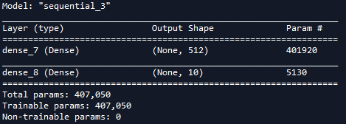

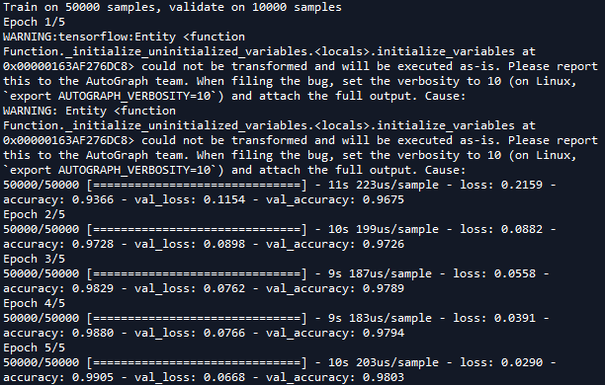

Model 2:  
3 Dense layers  
Relu activation function  
Sigmoid output function  
RMSprop optimizer with 0.001 learning rate

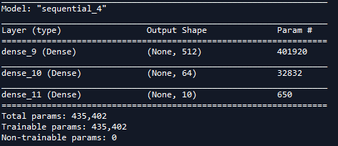

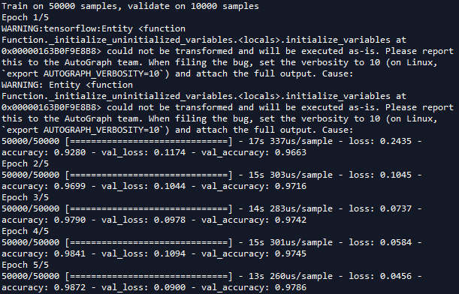

Model 3:  
2 Dense layers, 128 – output node  
Relu activation function  
Linear output function  
RMSprop optimizer with 0.01 learning rate

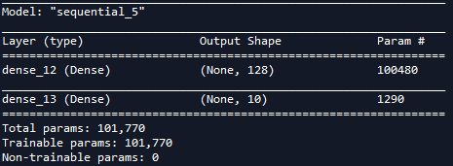

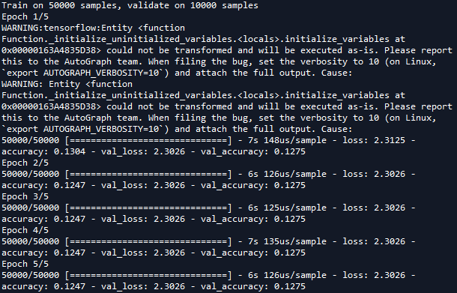

Observation:  
I trained the 3 models and tested those on the validation data. The performance of the 3rd model is the worst. Performance of 1st and 2nd model is almost similar. But 2nd model is a little bit better than the 1st model. I tested 2nd model on the testing data. After that I generated confusion matrix, accuracy, recall per class and precision per class.

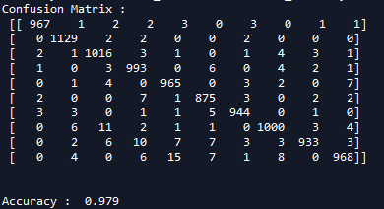

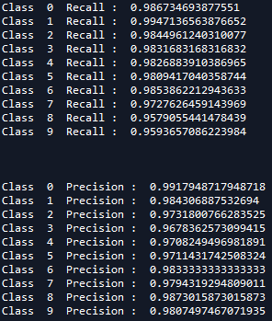

Next thing, I have done is the plotting of classified and misclassified images.

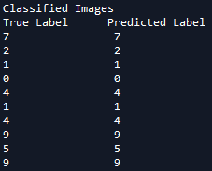

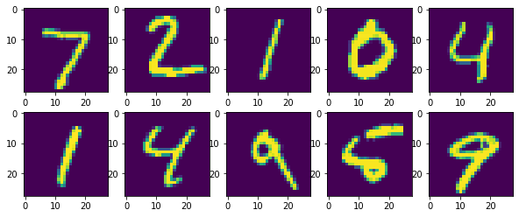

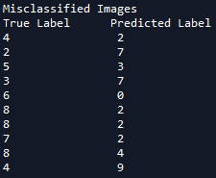

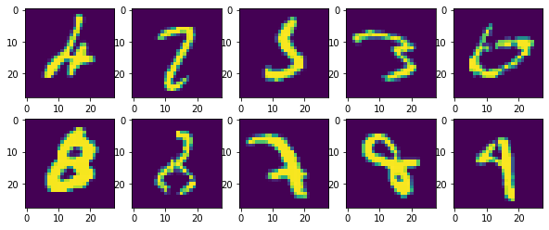

Few Reasons of Misclassifications:

* Blur images
* Resemblance with other digits

**Assignment 5 SVM:  
Problem Statement:**In this assignment, I tried to build a classifier that can identify the gender of a crab from its physical measurements. For every crab, there are six physical features: species, front-allip, rear- width, length, width and depth. We need to train a binary SVM model from a set of training samples and apply this model over the testing samples to evaluate its performance.

The dataset is provided in the file ‘crab.csv’, which 200 samples with gender labels (1: male, -1: female).

**Steps:**Step-1: First step is to load the data from ‘crab.csv’ to get feature matrix X and label vector Y.

Step-2: Then I divide the training set into two EVEN subsets: one for training the model, and anotherfor validation.

Step-3: Then, I tried out various values of C hyper-parameter keeping another parameter as fixed and keeping kernel as “Linear”. So, with this, I got the best C value.

Step-4: Then, with keeping the C value as best C value, I tried 3 different kernels “Linear”, “Polynomial” and “RBF”.

So, after this step, I got the best kernel value as well as best C value. Taking this combination into consideration, I trained the model and test it on test data.

Step-5:At last, I evaluated my model’s performance using confusion matrix and other metrics, including accuracy,precision and recall rates. I have also included 5 success examples and 5 failure examples in this report.

**3.1 Plot the validation errors using different values of C (with other model parameters fixed). Use at least 3 different values for C.**

**1) c_range = np.arange(1,10,0.5)**

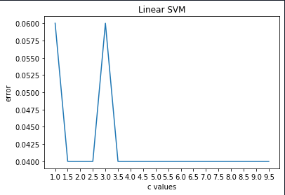

**3.2 Plot the validation errors while using linear, RBF kernel, or Polynomial kernel (with other hyper-parameters fixed);**

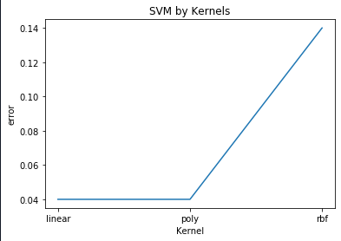

**Metrics:**

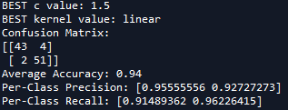

Step 6:  
Code was written to derive failure and true cases from the testing samples.  
Failure occurs when  
Case 1: Male is identified as female that is 1 is predicted as -1.  
Case 2: Female is identified as male that is -1 is predicted as 1.  
In all other cases true value predicted

**Output:**

